**GIT Assignment 1**

**Step – 1**

Install and Configure Git.

1. Chrome – search for windows GIT – RUN

**OR**

1. Install using Chocolatey

* Open chrome search chocolaty.org
* Chocolatey installation - copy the URL [command]
* Now open cmd as an Administrator
* Paste the copied command and Run
* Chocolatey installed.

1. Now either on cmd prompt CLI or from Powershell install GIT using Chocolatey.

* Administrator windows power shell –
* ps c:\windows\system32> choco install git – y

1. Once Git installed – Right click on desktop to check, We find GIT GUI & GIT Bash
2. Now Configure it with your name and email address –

git config --global user.name lakshmi

git config --global user.email [bslakshmi94@gmail.com](mailto:bslakshmi94@gmail.com)

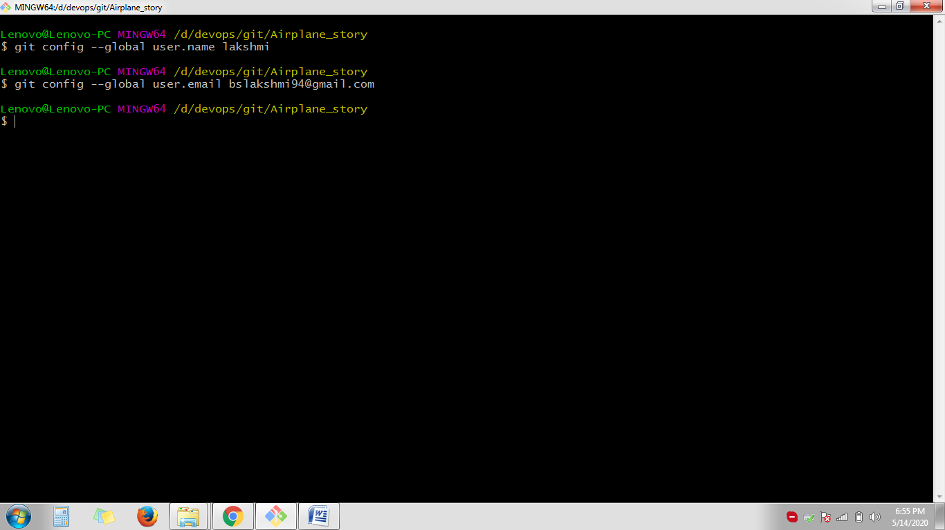

**Step – 2**

Clone the repository from https://github.com/satyensingh/content-git-quickstart.git to local and create a new branch “lakshmi” for the story.

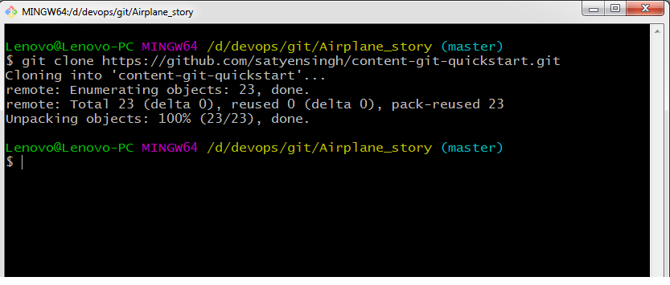

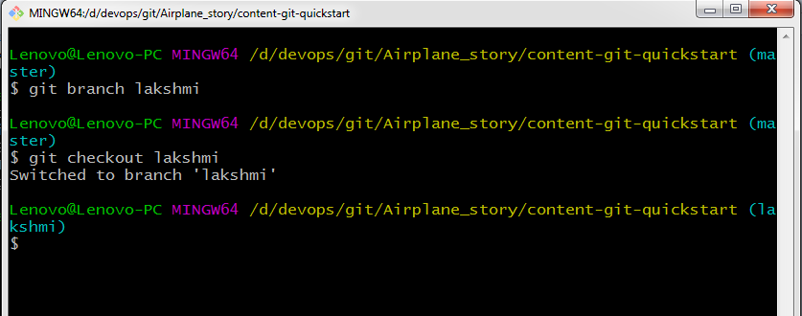

**Step – 3**

Add a new story file to local repository in your new branch “lakshmi”.

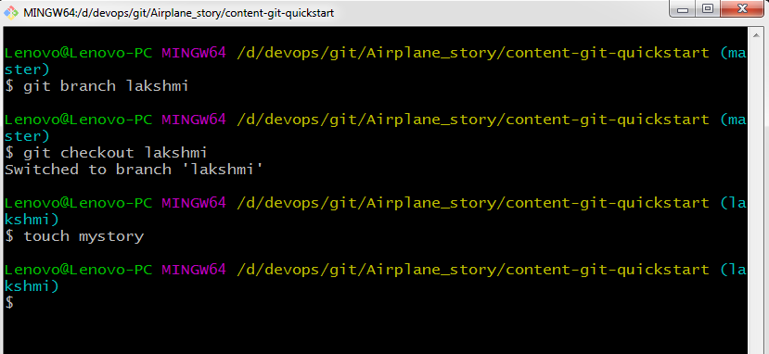

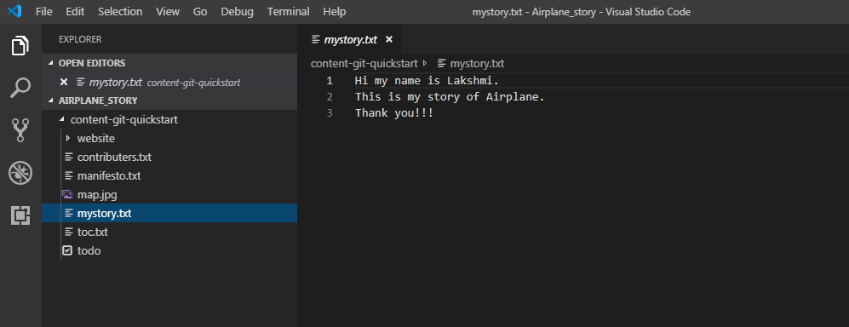

**Step – 4**

Add an entry to the file contributers.txt in this new branch “lakshmi”

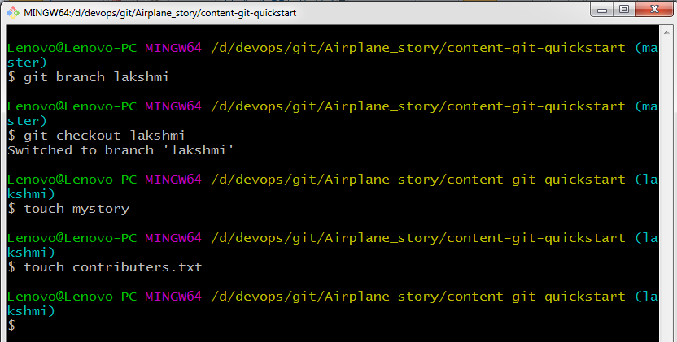

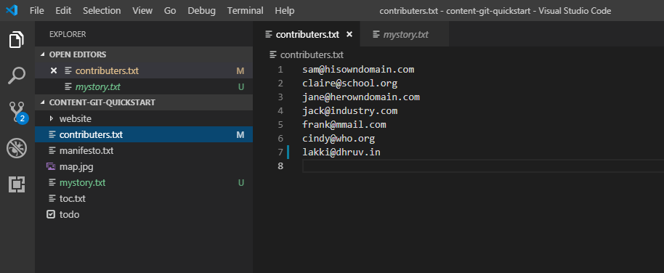

Added [lakki@dhruv.in](mailto:lakki@dhruv.in) under contributers.txt

**Step – 5**

track the work with git and commit the changes to local repository and use the commit message "airplane story" so the travel buddy will remember who I am.

1. To track the changes use – git status

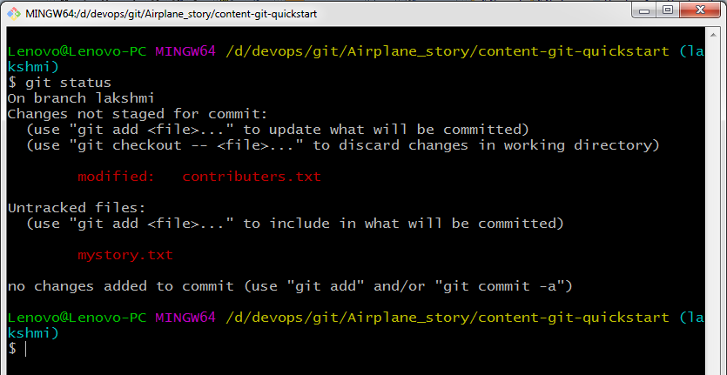

1. Now, git add to staging area then give git commit with message to commit to the local repo.

